**EXPERIMENT NUMBER –7**

**Student Name: Shinde Smita Shahaji UID: 20BCS4643**

**Branch: CSE (IOT) Section/Group: IOT (Group-B)**

**Semester: 2nd semester Date of Performance:04/23/2021**

**Subject Name: Quantum and Semiconductor physics lab**

**AIM OF THE EXPERIMENT** –To determine the divergence of laser beam.

APPARATUS-

|  |  |  |  |
| --- | --- | --- | --- |
| Sr.No. | Equipment | Range | Quantity |
| 1. | Power supply | 0-12V | 1 |
| 2. | Diode laser | 650nm | 1 |
| 3. | Stand | NA | 1 |

Diagram

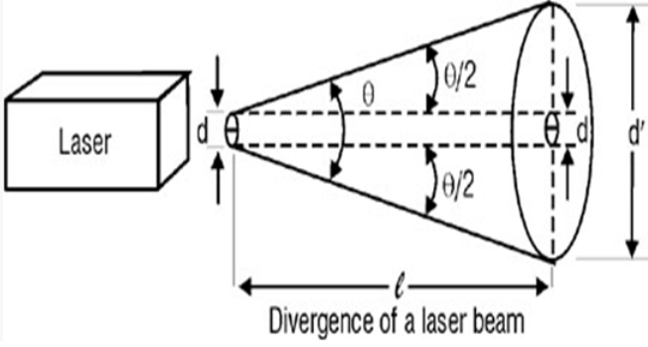

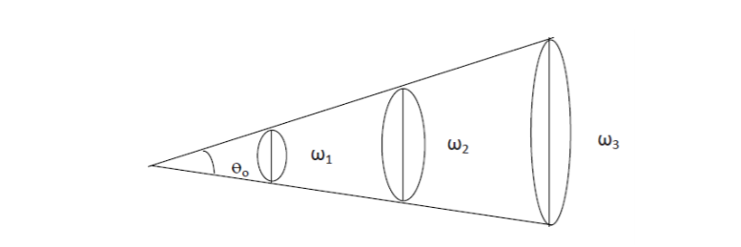

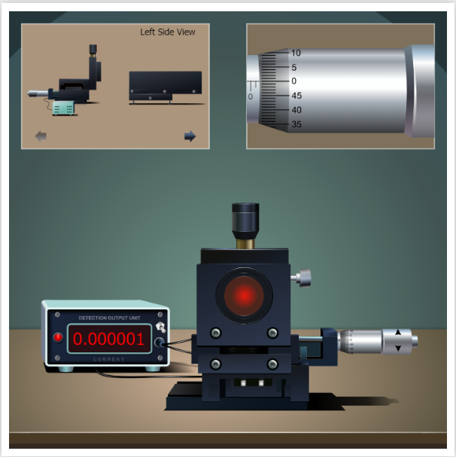

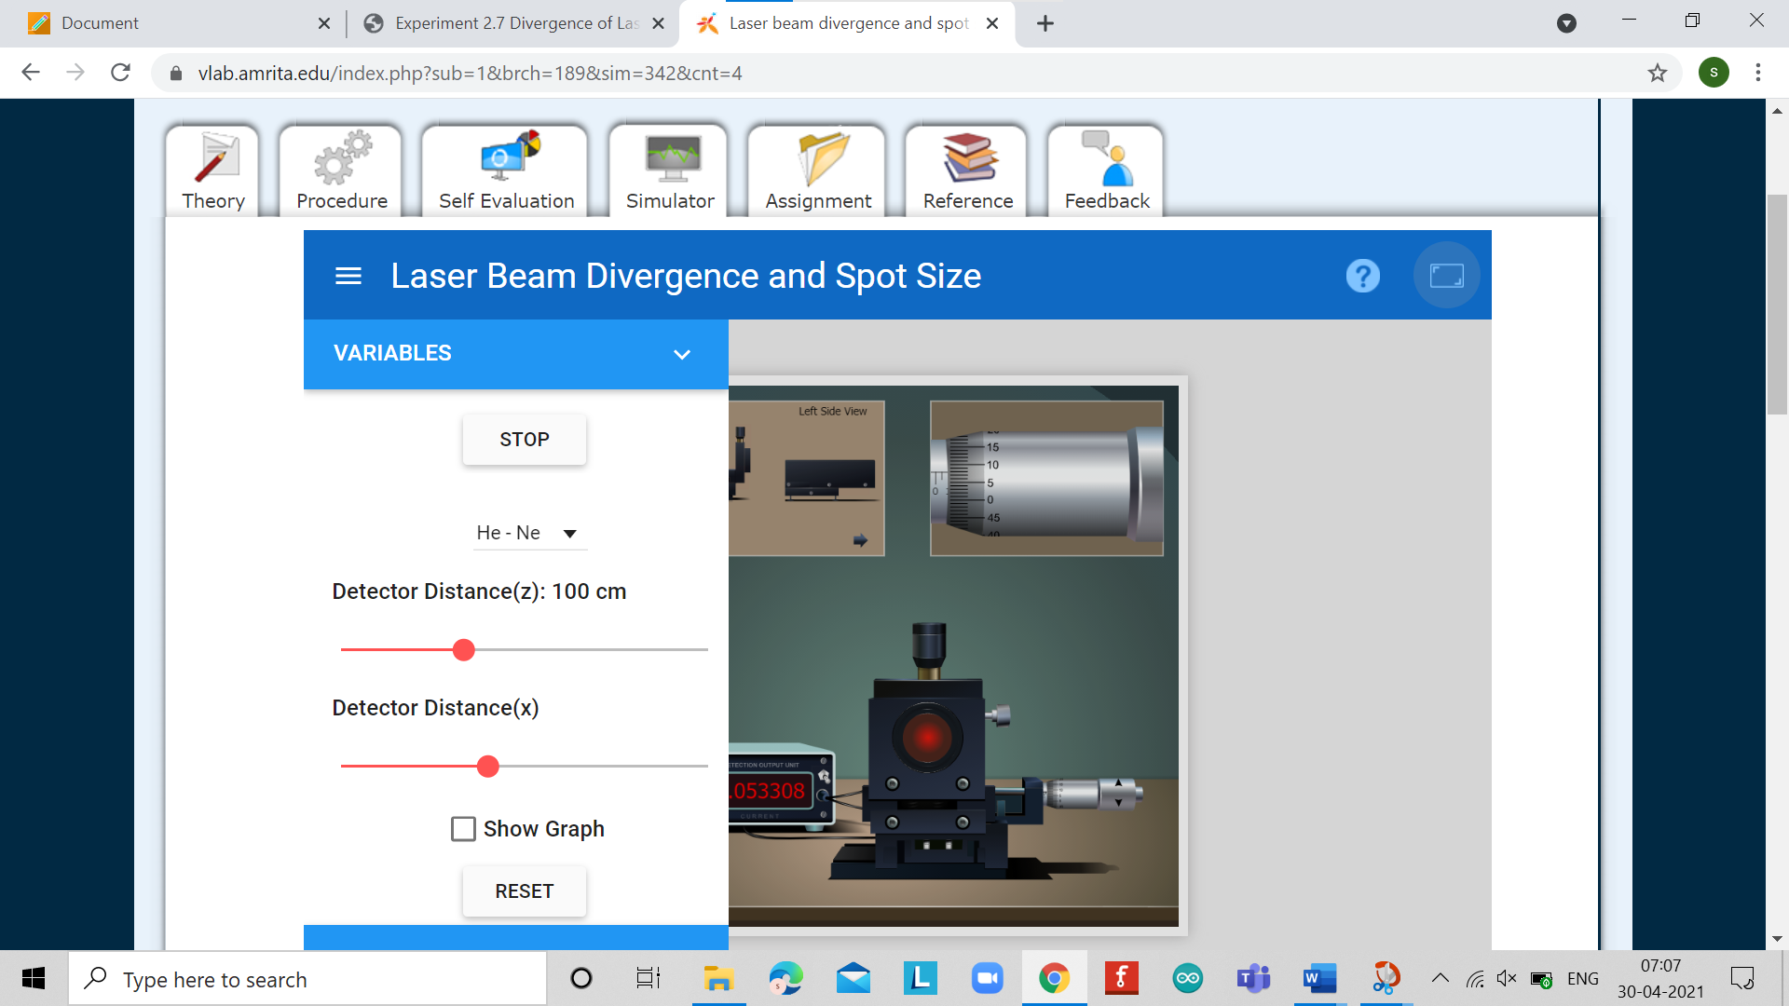

OBSERVATIONS-

Least count of screw gauge

One pitch scale division (n) = 1 mm

Number of divisions on head scale (m) = 100

Least count (L.C) =n/m = 0.01

For distance x formula = (main scale count + circular count *least count)

Detector distance value is constant(Z1) = 100cm

|  |  |  |  |  |
| --- | --- | --- | --- | --- |
| Sr.no | Distance X in mm | | | Current in mA |
|  | P.S. R. | H.S. R | Total |  |
| 1. | 0.7 | 0 | 0.7 | 0.000001 |
| 2. | 0.8 | 5 | 0.85 | 0.002094 |
| 3. | 0.9 | 7 | 0.97 | 0.034928 |
| 4. | 0.9 | 9 | 0.99 | 0.078292 |
| 5. | 0.9 | 10 | 1.0 | 0.090539 |
| 6. | 1.0 | 11 | 1.11 | 0.073906 |
| 7. | 1.0 | 14 | 1.14 | 0.031346 |
| 8. | 1.1 | 17 | 1.27 | 0.002107 |
| 9. | 1.2 | 20 | 1.40 | 0.000001 |

Detector distance value is constant(Z2) = 125cm

|  |  |  |  |  |
| --- | --- | --- | --- | --- |
| Sr.no | Distance X in mm | | | Current in mA |
|  | P.S. R. | H.S. R | Total |  |
| 1. | 0.6 | 0 | 0.6 | 0.000032 |
| 2. | 0.7 | 6 | 0.76 | 0.023789 |
| 3. | 0.8 | 8 | 0.88 | 0.056532 |
| 4. | 0.9 | 9 | 0.99 | 0.067212 |
| 5. | 0.9 | 11 | 1.01 | 0.072718 |
| 6. | 0.9 | 12 | 1.02 | 0.066130 |
| 7. | 1.0 | 13 | 1.13 | 0.058232 |
| 8. | 1.0 | 14 | 1.14 | 0.022424 |
| 9. | 1.1 | 20 | 1.30 | 0.000037 |

Formula

Imaxz1/e^2= d1

Imax of z^2/e^2=d2

1/e2 of maximum intensity,Ie = 0.135 mA

Divergence angle(Θ) = (d2-d1)/(z2-z1)

CALCULATIONS-

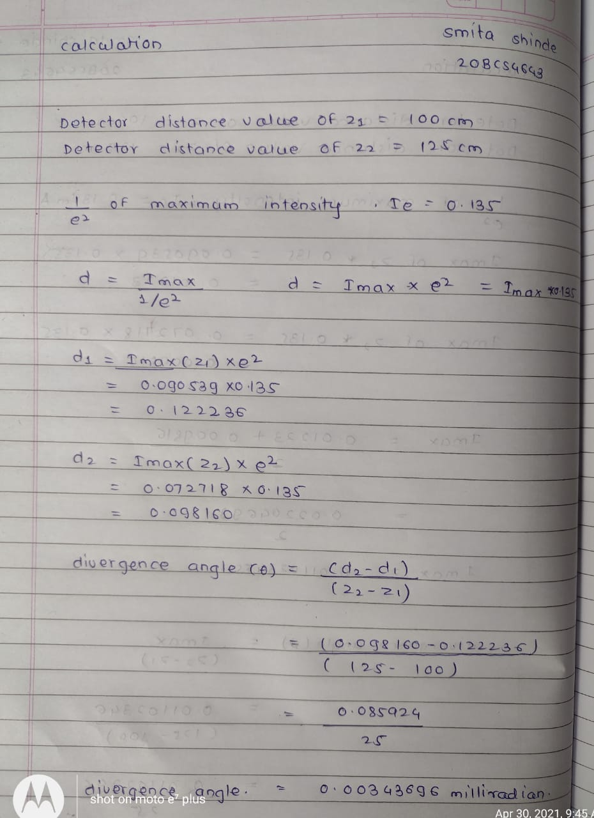

PERCENTAGE ERROR-No any percentage error

GRAPH (ATTACH IF ANY)-

No graph

SOURCES OF ERROR-

No any sources of error

RESULTS AND DISCUSSION-

**Result(s):** The angle of divergence of the diode laser is 0.00343696 milliradian.

**Conclusion:** Since this angle is very small (in the range of milliradian), we conclude that laser beam is highly directional as compared to ordinary light source.

LEARNING OUTCOMES

|  |
| --- |
| * It will provide the modest experience that allows students to develop and improve their experimental skills and develop ability to analyzedata. |
| * Ability to demonstrate the practical skill on measurements and instrumentation techniques of some Physics experiments. Students will develop the ability to use appropriate physical concepts to obtain quantitative solutions to problems inphysics. |
| * Students will demonstrate basic experimental skills by setting up laboratory equipment safely and efficiently, plan and carry out experimental procedures, and report verbally and in written language the results of theexperiment. |
| * Students will develop skills by the practice of setting up and conducting an experimentwithdueregardstominimizing   measurement error. |

EVALUATION COLUMN (To be filled by concerned faculty only)

|  |  |  |  |
| --- | --- | --- | --- |
| **Sr. No.** | **Parameters** | **Maximum Marks** | **Marks Obtained** |
| 1. | Worksheet completion including writing learning objectives/Outcomes. (To be submitted at the end of the day) | 10 |  |
| 2. | Post Lab Quiz Result. | 5 |  |
| 3. | Student Engagement in Simulation/Demonstration/Performance and Controls/Pre-Lab Questions. | 5 |  |
| 4. | Total Marks | 20 |  |
| 5. | Teacher’s Signature (with date) |  | |